DS-A2 | Inference and Uncertainty Notebook

Submission Report Course: Data Science

Complete document git-hub: https://github.com/alldeolove10-SJ/2026A8000531004_DEONISIO-YOHANES-WILFRIDUS-HORNAY_DS_A2_Inference_Uncertainty_Package__
Student Name | DEONISIO YOHANES WILFRIDUS HORNAY | Student ID | 2026A8000531004
Assignment | DS-A2 | Notebook Tittle | Inference and Uncertainty Notebook
Research Question | Does Group A have a higher average score than Group B?

Abstract. This report presents a complete inference and uncertainty analysis for the DS-A2 assignment. Instead of reporting only a single point estimate, the analysis quantifies uncertainty around the estimated difference between two groups using bootstrap simulation. The notebook defines a clear research question, states an estimand and hypotheses, constructs a sampling distribution, reports a 95% confidence interval, calculates an effect size, and discusses the limits of interpretation.

Objective and Requirement Alignment
The objective of DS-A2 is to use simulation and inference to quantify uncertainty rather than relying only on a point estimate. In response to the assignment requirements, this submission includes: (1) a defined research question and estimand; (2) hypotheses and a meaningful effect discussion; (3) simulation of the statistic’s sampling distribution; (4) a bootstrap confidence interval; (5) effect size analysis; and (6) a counterexample and limitation discussion.

Research Question, Estimand, and Hypotheses
Research question: Does Group A have a higher average score than Group B?
Estimand: The target quantity is the difference in population means, $∆=μ_{A}-μ_{B}$, where $μ_{A}$ is the mean score for Group A and $μ_{B}$ is the mean score for Group B.
Null hypothesis ($H_{0}$): $μ_{A}-μ_{B}=0$.
Alternative hypothesis ($H_{1}$): $μ_{A}-μ_{B}>0$.
Minimum meaningful effect: The analysis is not only concerned with whether the difference is positive, but also whether it is large enough to matter in practice. This is why the report includes both a confidence interval and Cohen’s d.

Dataset and Experimental Setup
The notebook analyzes a small two-group dataset stored in the package file data/ds_a2_sample_data.csv. Each observation is a score, and the unit of analysis is one recorded score. The executed notebook reported the following sample means:
Group A mean = 83.4
Group Bmean = 76.9
Observed mean difference (A $-$ B) = 6.5
A fixed random seed was used in the notebook to ensure that the bootstrap simulation is reproducible.

Point Estimate and Statistical Summary
The observed difference of 6.5 points suggests that Group A outperformed Group B in the sample. However, a point estimate alone cannot tell us how much uncertainty surrounds this estimate. The statistical summary below consolidates the key results from the notebook, including the sample means, observed difference, bootstrap confidence interval, and Cohen’s d.
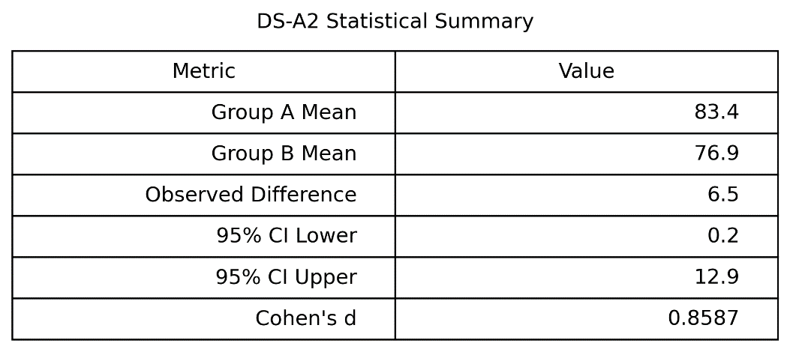
Figure 1: DS-A2 statistical summary produced from the executed notebook.

Bootstrap Sampling Distribution
To quantify uncertainty, the notebook uses bootstrap resampling. In each bootstrap iteration, observations from Group A and Group B are sampled with replacement, and the difference in sample means is recalculated. This process was repeated 5000 times, creating an empirical sampling distribution of the statistic.
This simulation-based approach is especially useful because it shows the spread of plausible mean differences instead of implying that the observed difference of 6.5 is exact. The resulting distribution is shown below.
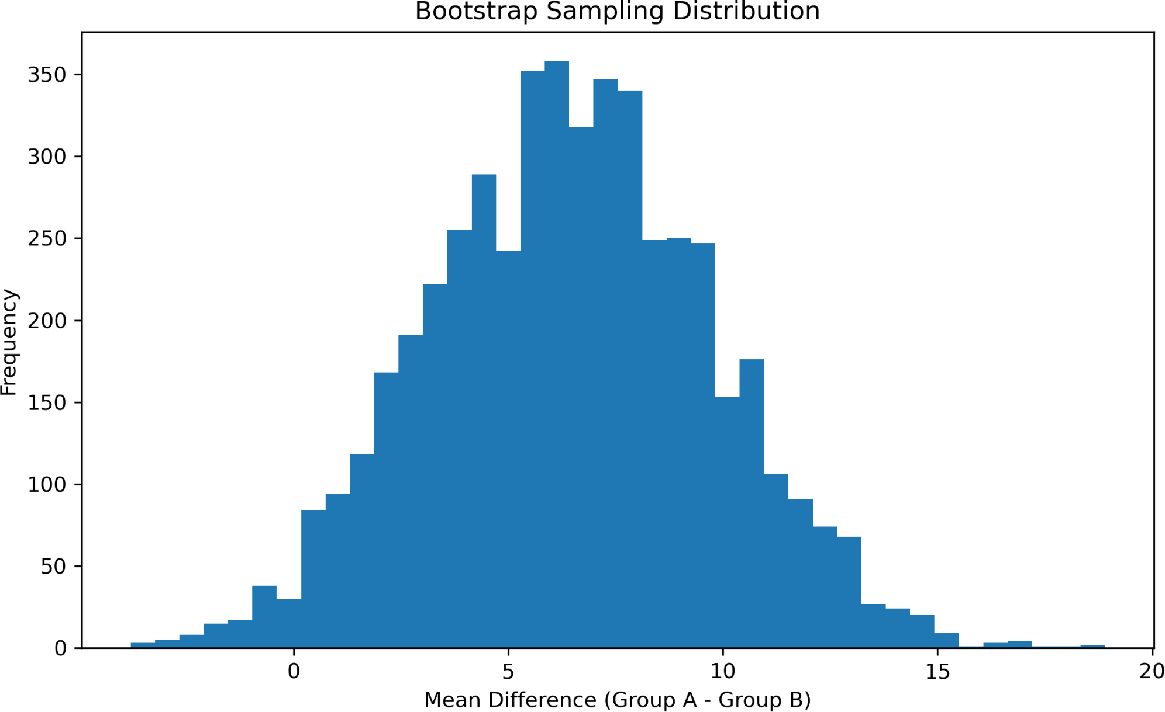
Figure 2: Bootstrap sampling distribution of the mean difference (Group A $-$ Group B).

Confidence Interval
Using the bootstrap distribution, a 95% confidence interval was computed from the 2.5th and 97.5th percentiles. The interval reported by the notebook is shown below.
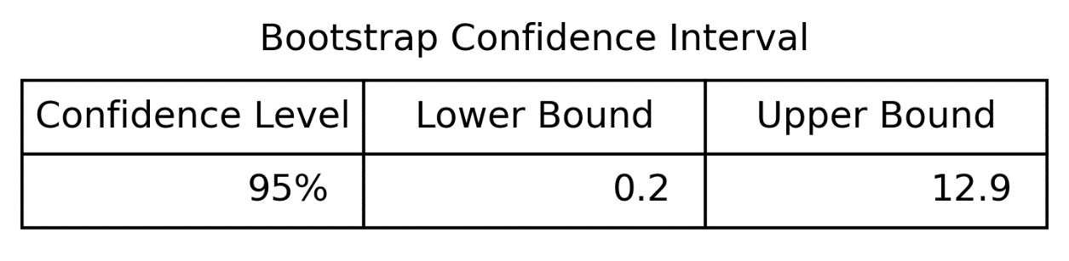
Figure 3: Bootstrap 95% confidence interval table.
The resulting interval is approximately [0.2, 12.9]. Because the interval is entirely above zero, the observed data are consistent with a positive mean difference in favor of Group A. At the same time, the interval is fairly wide, which shows that uncertainty remains substantial. This is an important part of the assignment: the evidence supports a positive difference, but the exact size of the difference is uncertain.

Effect Size and Practical Interpretation
Statistical inference answers whether a positive difference is supported by the data, but it does not by itself tell us whether the difference is practically meaningful. Therefore, the notebook also calculates Cohen’s d, a standardized effect size.
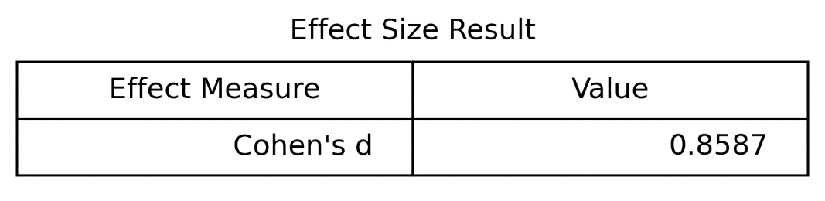
Figure 4: Effect size result produced by the notebook.

The notebook reports Cohen’s d = 0.8587. This is typically interpreted as a moderately large effect. In practical terms, the difference between the groups is not only positive in the sample but also meaningful in standardized units.

Sample Size, Noise, and Power Discussion
The reliability of any inferential result depends on sample size, variability, and the magnitude of the true effect. If the sample were smaller or the within-group noise were larger, the bootstrap interval would likely widen. Conversely, more observations would generally lead to a more stable estimate and a narrower confidence interval. This illustrates the assignment’s emphasis on uncertainty: even with a positive estimate, one should consider how sensitive the conclusion may be to data quantity and variability.

Counter example and Claim Boundary
A useful counterexample is the possibility of an unrepresentative sample. For example, if Group A in this dataset contains unusually high-scoring observations relative to its broader population, then the sample-based difference of 6.5 may exaggerate the true population difference. Similarly, if Group B were underrepresented or noisier than usual, the observed gap could change under a different sample.
Therefore, the analysis supports a bounded claim: in this dataset, the evidence is consistent with Group A having a higher average score than Group B, with uncertainty quantified by the bootstrap interval. The analysis does not support universal claims such as “Group A always outperforms Group B,” and it does not establish causation because no randomized intervention was performed.

Reproducibility and Verification
This submission is reproducible because the notebook uses a fixed random seed and generates exportable result files for the report. The notebook was executed successfully, producing the histogram and summary tables used in this PDF. The included results are consistent across the report: Group A mean 83.4, Group B mean 76.9, observed difference 6.5, 95% CI [0.2, 12.9], and Cohen’s d 0.8587.

Conclusion
This DS-A2 report demonstrates a complete inference-and-uncertainty workflow. The analysis begins with a clear research question and estimand, evaluates a point estimate, uses bootstrap simulation to quantify uncertainty, reports a 95% confidence interval, and supplements the inference with an effect size. The evidence from the sample supports a positive difference between the groups, but the report appropriately limits the claim by acknowledging uncertainty, sampling variability, and non-causal interpretation.

Appendix: Submission Checklist
  - Executed notebook (.ipynb)
  - This PDF report
  - AI verification log
  - Exported figures and tables in the Results folder
  - Google Drive / GitHub / learn.spaiq.ai links as required by the course submission guide.

